
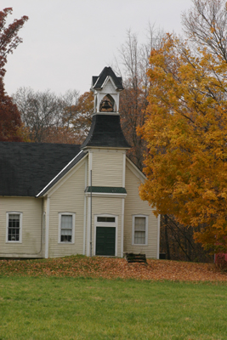
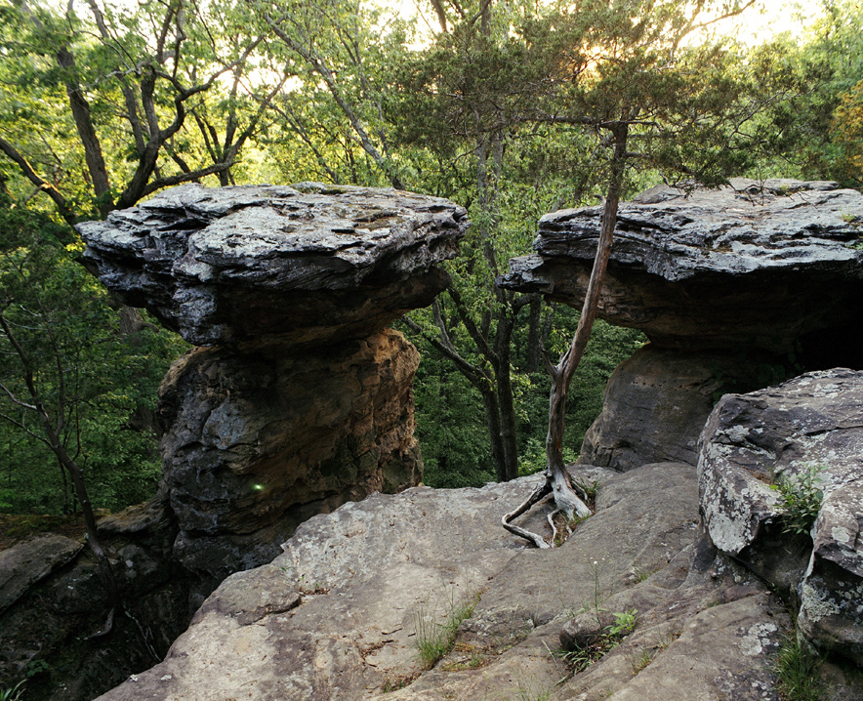
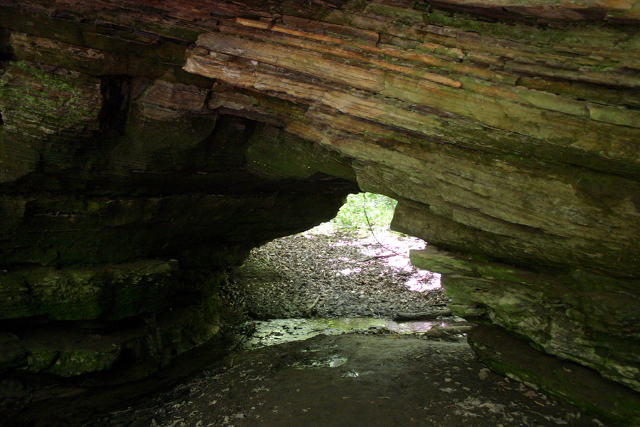
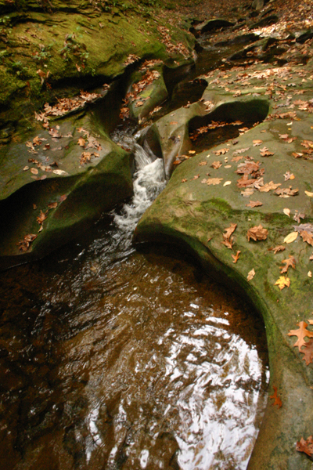

Woodrum-Media – 1619 N. Bowman, Danville, IL 61832

info@woodrum-media.com – http://www.woodrum-media.com – Phone: 217.443.4403
Media Notes

Inside This Issue
Fall Tours and Trips 1
Upcoming DACC Classes 2
Illiana Lifestyles Magazine 2
Photo Rummage Sale 3
Digital Photo Notes 3

Photo Tour of Southern Illinois
Fall, 2008
Volume 1, Issue 3

Two Fall Colors Photo Trips Planned for This Season
Join Les on a six hour excursion to local scenic sights within 35 miles of Danville. The trip will start out at 7:00 a.m. on October 25th and head to some of Les’s favorite spots to photograph in Western Indiana. This workshop will assist participants in all aspects of scenic photography, shooting any format, digital, film, medium format, or view camera usage.

Les Woodrum will be hosting two different photo tours that will explore photographing beautiful Fall colors in central Indiana and Southern Illinois.

This trip will concentrate on the south-west scenic areas of Southern Illinois. The workshop will center from the Carbondale, Il area.
Areas to be visited will include Giant City State Park, Pine Hills, the Cache River Swamps and a local winery. The price for this workshop will be $120.00 per person (Spouses are free). Transportation, meals and lodging will be in addition to the class fee.
Cont. on Page 2
Half Day Trip Through Western Indiana
Tree Roots – Giant City
The Potholes –
Williamsport, IN
Participants will be responsible for their own transportation, but the class will travel in a caravan from location to location. A lunch stop (self paid) will be included during the trip.

Cost for the “Western Indiana Fall Colors Tour” is only $35.00 per participant. An optional critique session following the tour for those using digital formats will take place at Les Woodrum’s house after the trip.

Portland Arch, IN
Deadline for registration is October 23, 2008. To register, contact Les at lesw@woodrum-media.com andput “Indiana Photo Tour” in the subject line. You can also call Les at 217-443-4403.

Table Rock – Giant City

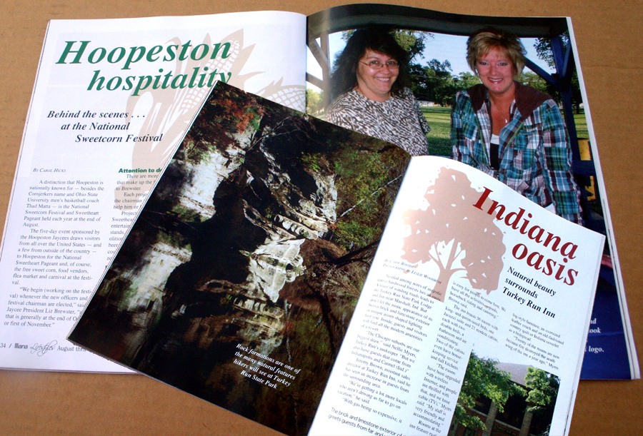

Photography, Web Design, & Digital Imaging Classes at DACC
It is still not too late to sign up for the last three “Visual Communications” classes offered during the fall semester at DACC (taught by Les Woodrum). The three remaining classes this year include:
Digital Photography
Traditional film is almost a thing of the past. This workshop will emphasize digital photography techniques, explain digital photography terms, camera operations and settings, basic photo manipulations, and file management of digital images.
Lincoln Hall, Rm. 218
Mondays, October 27–November 19,
6-8 p.m. $96

PHOTOSHOP
This class will introduce you to the basics of working with Photoshop for retouching images and drawing. Students will be able to use various techniques for selecting in order to edit and retouch images. Students will be able to prepare images for including in a website or for including in printed documents. Students will be able to edit images using the painting tools, clone stamp and drawing tools. Students will be able to create new images using the pen tool and the drawing and painting tools. Students will be able to create and edit images using layers.
Lincoln Hall, Rm. 218
Saturdays – November 29 – December 20,
9am to Noon, $96

Dreamweaver
Learn how to make a basic website using one of the most powerful web authoring programs available. In this workshop, you will learn how to construct basic web pages, templates and graphics, make links and publish the web site.
Technology Center, Room 136
October 22 – November 12, Wednesdays
6-9 p.m. $96.00
Deadline for Registration for this workshop is October 29, 2008.To register for this workshop, contact Les at lesw@woodrum-media.com and put “Southern Illinois Trip” in the subject line. You can also call Les at 217-443-4403 to register.
Illiana Lifestyles Magazine
You should check out a new quarterly publication published by The Commercial News. The magazine is called “Illiana Lifestyles.” The first issue hit the newsstands in early May. The fall issue came out on August 1st. The Winter issue should hit newsstands on November 1st.

I have a special interest in this publication because I am one of the contributing photographers for this magazine.

The magazine is a full-color publication printed in very high quality. A subscription costs $9.00 per year. Call 217-446-9494 for information and subscription requests. Single issues can be purchased at many local vendors including: Attica, Hoopeston &Covington IGA, Molly Culberts – Hoopeston, Priceless Foods, Danville County Market & local Walgreens Pharmacies. You can also e-mail the magazine at info@illianalifestyles.com

Horseshoe Lake Cypress – Cache River area

A Full Schedule of Digital Imaging
and Photography Classes to be
offered by DACC this Spring
Schedules are not finalized yet, but a full compliment of “Visual Communications” classes will be offered by DACC this spring semester. Classes being planned for the Spring semester include:
- Photography – The Basics
- Dreamweaver – Web Page Design
- Macromedia Flash – Advanced Web Page Design
- Digital Photography
- PhotoShop – CS3
- PhotoShop Elements 5.0

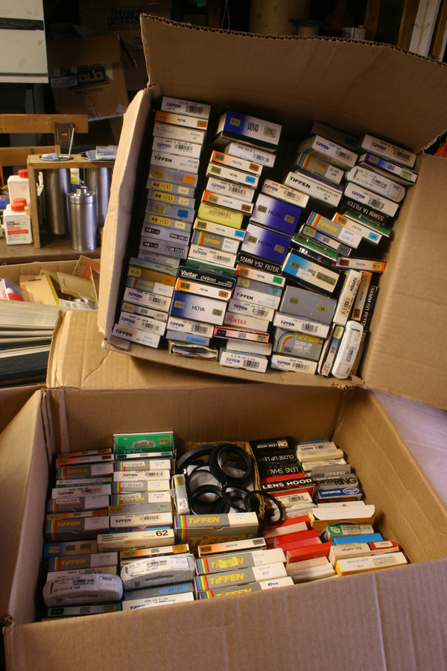
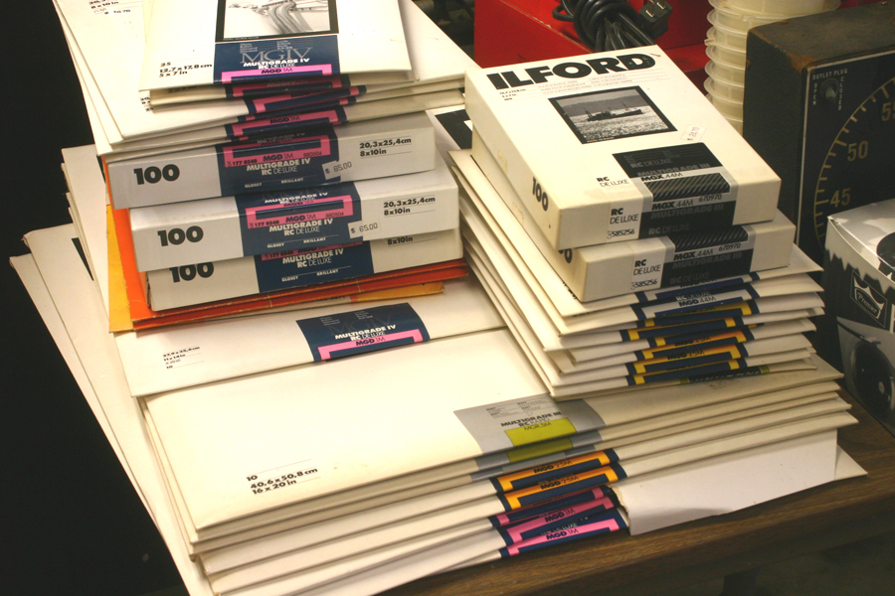
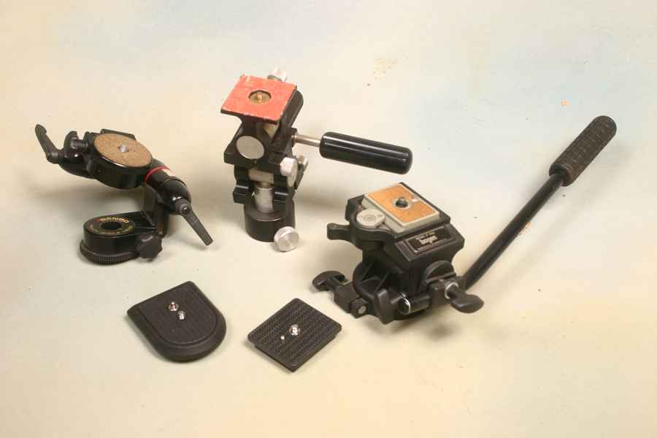

Photo Rummage Sale
Woodrum-Media is in charge of the liquidation of all of the photo equipment and supplies for a local camera store that went out of business. Items are being sold for pennies on the dollar. There are some larger items that do have a reserve price on them. Some of the “stuff” that has been salvaged includes:
- Beseler 4x5 enlarger
- Lots of assorted lenses (probably 20 or more) especially Yashica/Contax lenses.
- Camera bags, all shapes, all sizes
- Darkroom supplies and equipment
- Filters galore from 38mm to 72mm
- Cokin special effects filters
- Flash units – lots of different brands
- Studio backgrounds
- Tripods and tripod heads
- Folders, negative sleeves/preservers
- Misc. camera accessories

To check out the “stuff”, give Les a call at 217-443-4403 after 4:00pm or on weekends.

About six items every two weeks are being sold on e-bay. To check out current listings, search for items sold by leswphoto.

Digital Photo Notes
In 1981, Bill Gates, the founder of Microsoft was quoted as saying “640K of memory should be enough for anybody.'' Twenty-seven years later, that is not enough memory to record even a single digital image.

This year, 2008 marks my tenth year of using digital cameras for commercial photography. I still own my first Sony Mavica camera I purchased, and it is still being used on a regular basis.

But the most often asked questions in classes and workshops I teach is, “what do you do to manage all of these files?” Let me briefly try to outline what I do when storing away my digital files.

First of all, I do not reformat the memory card that was in the camera until at least two back-up files of the card have been saved. When I am on the road, this requires having a laptop with a CD burner. When I am at home, I utilize an external hard drive to store the images, but I still burn two copies onto CD.

I use the external hard drive on the home computer to store the images because for one, having the photos there does not slow down my computer because of the hard drive filling up. I can also add more external hard drives should I fill one up.

But the main practice I try to do is to always burn two CD’s of the images. I store one copy in the house in a notebook with a thumbnail contact page attached. The other copy gets stored in my detached garage that is 40 feet away (in case of fire in one structure or the other).

My biggest suggestion for those just getting started in digital photography would be to keep your photo files stored somewhere else other than your computer’s hard drive. How many times have you heard about (or it did happen to you) that someone’s computer crashed and all files were lost? It seems as if computers have a built in time bomb set to crash after three to five years of service.

My son Dallas was attending college in Taxco, Mexico over the summer. Needless to say, his computer crashed while away from home. Luckily, he had downloaded most of his images to a photo file-sharing web site, and the memory card on the camera still had most of his photos from the trip. But I never thought to take the time to tell him about backing up his images. When on the road, I do this on a daily basis.

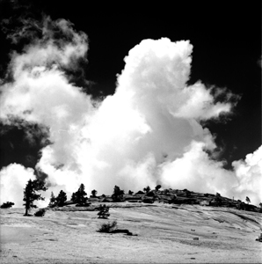

Woodrum-Media
1619 N. Bowman
Danville, IL 61832

Phone:
217.443.4403

E-Mail:
info@woodrum-media.com
All Photos © Leslie A. Woodrum

We’re on the Web!
Visit us at:
http://www.woodrum-media.com
Your Solution for Photography, Web Page & Media Design, Communications Education and Training

Woodrum-Media
1619 N. Bowman
Danville, IL 61832

Photo of the Quarter
“Olmstead Point” – Yosemite National Park

Sometimes, a photo just jumps out and says ”look at me” which this one of Olmstead Point at Yosemite has done to me. This would be a real good example of when to use a red filter when photographing in black & white. There was no special darkroom techniques utilized to make the contrast between the sky and the clouds pop.

Camera – Bronica SQa w/150mm lens
Film – Kodak T-Max 100 & T-Max Developer 1:4
Exposure – 1/15 sec., f/16 w/#25 red filter

